ENTERPRISE ENDPOINT MANAGEMENT
Sync Your Surface
Five clicks, about two minutes
A sync tells your Surface to check in with the university right now instead of waiting. Run one when your course software or class links have not shown up yet.

Which handout do you need?
This document is for a Surface that was set up but has not received its apps or class links yet.
If you reach Step 4 and there is no Info button on your account row, STOP. Your Surface has not finished setting up, and a sync will not help yet. Use the Finish Setting Up Your Surface handout first, then come back here.

The short version: Settings > Accounts > Access work or school > your account > Info > Sync

Step 1 Open Settings and click Accounts
Press the Windows key, type Settings, then press Enter. Click Accounts in the list on the left.


Step 2 Click "Access work or school"
Scroll down the Accounts page until you see it.
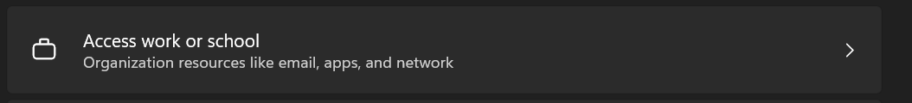

Step 3 Click your account
Click the row with your university email address. It opens up.
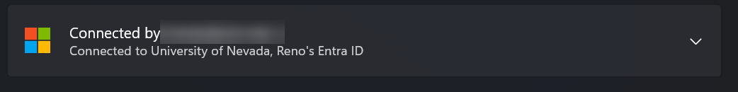

Step 4 Click "Info"
The button sits next to "Managed by University of Nevada, Reno".
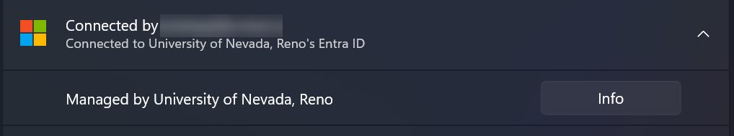

Step 5 Scroll down and click "Sync"
Scroll to the bottom of the Info page to find Device sync status, then click Sync.
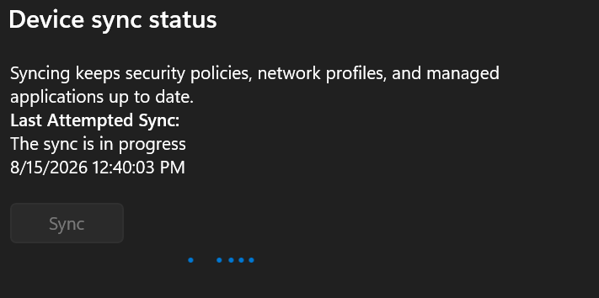
You did it right if
The Sync button greys out and blue dots move across the screen. That is the sync running.
You are finished when the line under Last Attempted Sync shows a date and time.
Your apps and class links arrive over the next half hour. You can close Settings and keep using your Surface.

If something goes wrong
What you see | What it means | What to do
The Sync button is greyed out | A sync is already running. | Wait five minutes, then check again.
An error code appears instead | Your Surface cannot reach the university right now. | Check your Wi-Fi, wait a minute, then press Sync again.
There is no Info button on your account row | Your Surface has not finished setting up. A sync will not help yet. | Use the Finish Setting Up Your Surface handout first, then come back here.
The sync worked but an app is still missing | Downloads keep running after the sync finishes. | Wait 30 minutes, restart your Surface, then look again.
Still stuck? Contact the DWPI team or the OIT Help Desk. Have your Surface device name ready, found under Settings > System > About.

